Thermodynamics
1. Refer to the following information for the next four questions.

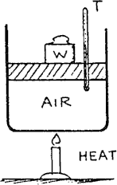
A mass of air is contained so that the volume can change but the pressure remains constant. This would be an example of an isobaric process.

Table I shows air volumes at various temperatures when the air is heated slowly.
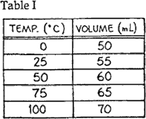

a. Plot the data in Table I on the graph paper provided. State the equation of the trendline. b.
- The graph shows how the volume of air varies with temperature at constant pressure. The straightness of the line means that the air expands uniformly with temperature. From your graph, you can predict what will happen to the volume of air when it is cooled. Extrapolate (extend) the

straight line of your graph to find the temperature at which the volume of the air would become zero.

- Although air would liquefy before cooling to this temperature, the procedure suggests that there is a lower limit to how cold something can be. This is the absolute zero of temperature. Careful experiments show that absolute zero is ºC.

- Scientists measure temperature in Kelvin instead of degrees Celsius, where the absolute zero of temperature is 0 K.
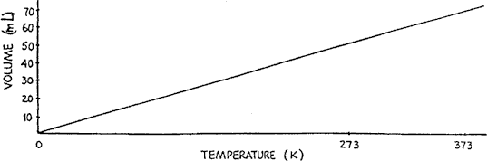

  - If you relabeled the temperature axis on the graph in Question 1 so that it shows temperature in Kelvin, would your graph look like the one shown above?
3. Refer to the following information for the next eight questions.

A major puzzle faced scientists in the 19th century. Volcanoes showed that the earth is molten beneath its crust. Penetration into the crust by bore-holes and mines showed that the earth's temperature increases with depth. Scientists knew that heat flows from the interior to the surface. They assumed that the source of the earth's internal heat was primordial, the afterglow of its fiery birth. Measurements of the earth's rate of cooling indicated a relatively young earth - some 25 to 30 million years in age. But geological evidence indicated an older earth. This puzzle wasn't solved until the discovery of radioactivity. Then it was learned that the interior was kept hot by the energy of radioactive decay. We now know the age of the earth is some 4.5 billion years - a

much older earth.

All rock contains trace amounts of radioactive minerals. Radioactive minerals in common granite release energy at the rate 0.03 J/kg/yr. Granite at the earth's surface transfers this energy to the surroundings practically as fast as it is generated, so we don't find granite any warmer than other parts of our environment. But what if a sample of granite were thermally insulated? That is, suppose all the increase of internal energy due to radioactive decay were contained. Then it would get hotter.

How much? Let's figure it out, using 790 J/kg/K as the specific heat of granite.
a. How many joules are required to increase the temperature of 1 kg of granite by 1000 K?

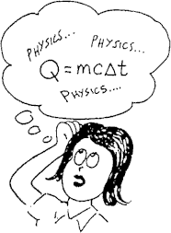
  - How many years would it take radioactivity in a kilogram of granite to produce this many joules?

  - How many years would it take a thermally insulated 1-kilogram chunk of granite to undergo a 1000 K increase in temperature?

  - How many years would it take a thermally insulated one-million-kilogram chunk of granite to undergo a 1000 K increase in temperature?

  - Why does the earth's interior remain molten hot?

  - Rock has a higher melting temperature deep in the interior. Why?

  - Why doesn't the earth just keep getting hotter until it all melts?

  - True or False? The energy produced by earth radioactivity ultimately becomes terrestrial radiation.
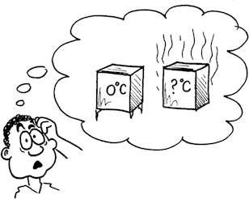

- A piece of iron has a temperature of 0°C. A second identical piece of iron is twice as hot. What is the temperature of the second piece of iron?
- A piece of iron has a temperature of 10°C. A second identical piece of iron is twice as hot. What is the temperature of the second piece of iron?

- Review: If you accidentally touch the inside of a 200°C hot oven you will burn yourself. But when the 1200°C white hot sparks from a 4th-of-July-type sparkler hit your skin, you're okay. Why?

7. Refer to the following information for the next three questions.
On a hot day, a student places a glass of cold lemonade on a table outdoors. After a few minutes, water droplets have formed on the outside of the glass.
  - Is energy absorbed or released by the cold lemonade? Explain your answer.

  - Compare average kinetic energy for the air molecules and lemonade molecules when the student first places the lemonade outdoors. Explain your answer.

  - Explain how and why the water droplets form on the outside of the glass.

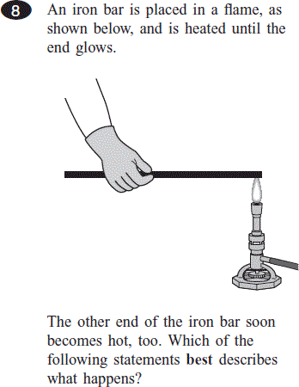

A. A convective flow of energy is set up inside the iron bar.
B. Energy is conducted from atom to atom along the length of the iron bar.
C. Radiation moves through the iron bar and is absorbed by the end not in the flame.
D. Air heated by the flame radiates down the iron bar and heats the end not in the flame.

- State the First and Second Law of Thermodynamics:

- When you leave an outside door open on a cold day, does the cold come in or the heat go out?

- What is the difference between thermal energy and internal energy of a perfect gas?

- What is the interval between the ice and steam points of water on the Kelvin scale? What does the perfect gas law predict the volume to be at absolute zero? Does this actually happen? Explain.

- The calorie is defined in terms of the Celsius temperature unit. How would the definition differ if it were defined in terms of the kelvin?
- (a) About a century ago James Joule performed a whole series of experiments which led to the enunciation of the Law of conservation of energy (Joule was the son of a wealthy brewer and could devote a lot of time to experimental work). In his most famous experiment he allowed two masses, each 14 kg, to fall 20 times through 2 m. What was the total amount of Potential Energy Lost. (Remember, P.E. = mgh)

(b) If all that energy were converted into heat energy, what rise in temperature could Joule expect in the 7 Kg of water that he used? (The specific heat capacity of water is 4200 J/kg K.
Remember that the magnitude of a kelvin in the same as that of a degree Celsius)

14. Review: Refer to the following information for the next four questions.

A student heats a 200 g sample of water from 20°C to 80°C. The specific heat of water is 4.18 J/g • °C.

- Calculate the thermal energy absorbed by the water. Show your calculations and include units in your answer.

The student then boils the water.

- Describe what happens to the temperature of the water as it boils. Explain your answer.

The student repeats the experiment, this time placing a small block of iron into another 200 g sample of water. The specific heat of iron is 0.45 J/g • °C. Both the iron and the water are initially at 20°C and are heated to 80°C.

- Compare the amount of thermal energy absorbed by the water in this experiment with your calculation in part (a). Explain your answer.

- Describe how repeating the second experiment with a block made of a material with a greater specific heat will affect the amount of time it takes to heat the block. Assume the blocks have the same mass.

C. 168,000,000 J | D. 210,000,000 J

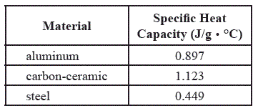
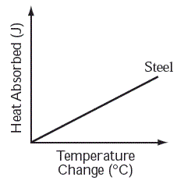
15. REVIEW: Refer to the following information for the next two questions.

A car’s brakes absorb a large amount of energy and heat up as the car slows down and stops. Several materials with different thermal properties have been used for car brakes. In the table below, the specific heat capacities of three of these materials are shown.

In an experiment, 500-g each of aluminum, carbon-ceramic, and steel are heated and their temperature changes are recorded. The amount of heat absorbed and the temperature change for the 500-g sample of steel are shown in the graph below.

- • Draw a line on your graph to show the relationship expected for the 500-g sample of aluminum.
- • Draw a line on your graph to show the relationship expected for the 500-g sample of carbon- ceramic.
- • Identify each line on your graph, and explain why you drew each line where you did.

- If brake materials get too hot they soften or melt, resulting in loss of braking power. Of the three materials in the table, which is best suited to resist large changes in temperature? Explain your answer.

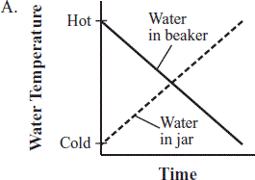
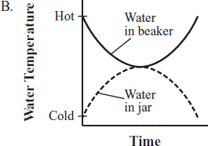
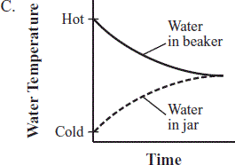
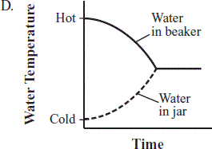
  - REVIEW: A sealed glass jar containing 200 mL of cold water is lowered into a large beaker containing 200 mL of hot water. Which of the following graphs shows how the temperature of each water sample will most likely change over time?

  - REVIEW: The table below shows data from a heating experiment
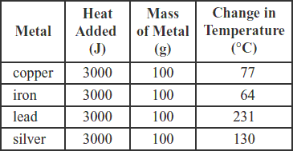

Which of the following conclusions is supported by the data in the table?

    - A given mass of silver requires less heat to change its temperature 1ºC than an equal mass of

iron.

    - A given mass of silver requires less heat to change its temperature 1ºC than an equal mass of

lead.

    - A given mass of copper requires less heat to change its temperature 1ºC than an equal mass of lead.

    - A given mass of copper requires less heat to change its temperature 1ºC than an equal mass of silver.

  - A student places four identically sized metal blocks on a hot plate at 80°C. Then the student places an identical piece of wax on top of each block, as shown in the diagram below.
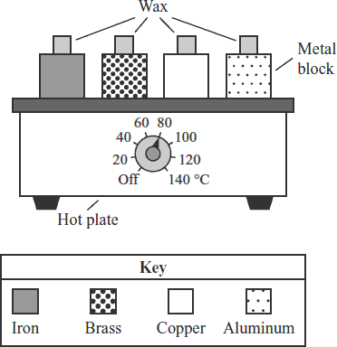

The student measures the time it takes for the piece of wax on each block to melt. Which of the following questions is being studied in this experiment?

A. What is the melting point of the wax?
B. What is the melting point of each metal?
C. Which metal radiates heat the best?
D. Which metal conducts heat the best?

